Moldova, what we know about the refugee crisis
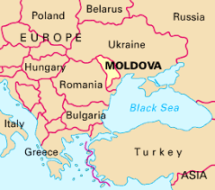
Moldova is a small country with a population of 2.6 million and lies to the south of Ukraine. Before the Ukrainian refugee crisis, Moldova already had a complex set of challenges including an unstable government with routine and unpredictable shifts in the highest levels of government and heavy outmigration due to labor (in fact, of the nearly 42,000 children in the country living outside of parental care, 88% of those are resulting from parents living in other countries for work). In the past two years, the COVID 19 pandemic contributed to an economic recession and now prices of natural gas imported from Russia are increasing, causing further strain on an already strapped economy (source: Economist).
The war that Russia started in Ukraine has resulted in around 280,000 Ukrainian refugees flooding into Moldova with over 100,000 remaining (as of March 11 per UNCHR). With increasing attacks throughout Ukraine, we can expect the number of refugees to grow. According to Moldovan foreign affairs minister Nicu Popescu and the BBC, 1 in 8 children in Moldova is a refugee child and during the last two weeks, the population of Moldova has increased by 4%. Already fragile social services are now being taxed - UNCHR has reported that Moldova has the highest per capita refugees in the region and a recent article in the Economist quoted Minister. Popescu as saying, ‘The prospects are dire, we are talking about a major threat to the whole state system.” The situation would become unbearable for Moldova if Odessa comes under siege, as there are 1-million inhabitants in that city located on the coast of the Black Sea, 100 km away from Moldova (Palanca border crossing point).
The government of Moldova and its strong civil society sector has been working closely with the international community (e.g., the European Union, UNCHR, UNICEF, WHO, various embassies) to support the refugees – setting up refugee centers, helping transport refugees to other countries, providing medical and social support services, and caring for unaccompanied children crossing the border). Here are some of the key initiatives underway as reported by Palladium staff in country:
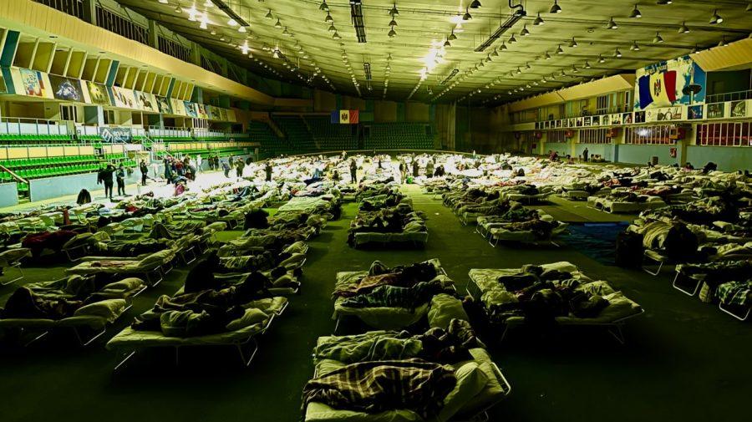
- The government of Moldova, – as of March 8, has established 96 accredited Refugee centers established by the National Social Assistance Agency (NSAA). An additional 200 places for temporary accommodation were created all over the country by the other Ministries, Local Authorities, or Private Entities. The Ministry of Labour and Social Protection has also set up a data collection process to capture data on the centers, number of available beds and primary refugee needs. The Government is also preparing a cash support system for the refugees as well as for the Moldovan families who are hosting Ukrainian refugees. There is also a website dopomoga.gov.md where the Moldovan Bureau of Migration and Asylum is providing up-to-date information for refugees. Public hospitals are providing priority free of charge medical assistance to pregnant women, people with cancer and any other refugee in need of emergency health care

- Civil society and people of Moldova are providing tremendous support to cover basic needs (food and water, shelter, clothes, medicines, emotional relief, transportation); there are several support groups on social media (Facebook, ViberTelegram) which are used to connect with refugees, learn about their needs and provide quick support (e.g. https://www.facebook.com/groups/347615063908402/. An infocenter for Ukrainian refugees has been created using a popular marketplace website to provide information about housing, transportation, healthcare.
- UNICEF is leading the child protection emergency services to refugee children and mothers arriving in Moldova at Blue Dot centers (services in one location for families on the move, providing sustenance, respite, information, guidance and psychosocial support, among other services)
- WHO is coordinating implementation of the needs assessment and a costing tool for health sector refugee response – with various predictions of services needed based on the number of refugees who will stay in country
- UNCHR is taking the lead on coordinating international community support and publishing data related to the refugee situation, which is available at: https://data2.unhcr.org/en/situations/ukraine; they are also leading information management activities at the inter-agency level

- The International Office of Migration is collecting data at the point of entry from Ukrainian borders (for arrivals) and the Romanian borders (for departure) to avoid double counting.

- There are also many examples of private sector helping Ukrainian refugees, from providing free internet and sim cards, coworking spaces, financial services, offering free clothes and meals.
Additional complexities exist that will need to be addressed. For example:
- Approximately 2/3rd of refugees are staying within the communities – ensuring that those refugees, their host families and community needs are supported will be a challenge.
- Approximately half of Ukrainian refugees are remaining in country, the other half transitioning to the other countries – managing that flow and ensuring needs are met will be critical to address. For example, the Palladium D4IChief of Party has identified requests for support on transportation from the entry border crossing points to airports or other transportation avenues to the West, and for affordable accommodation (from short to long-term)
- Adult refugees are coming in with no work or opportunities to work, in a country that already struggles with labor issues – finding work for refugees within/outside of Moldova and opportunities for language courses and professional reconversion will be critical.
- One in 8 children in Moldova is a refugee, some of whom are unaccompanied, making sure those children are properly placed, integrated into society, and receiving education and other critical mental health and social support services will be crucial.
- Within such a small country, there are many actors and external groups wanting to support the country – ensuring coordination with the lead UN agencies and government partners is of utmost importance.
Given this set of challenges, the need for rapid, efficient, automated, and scalable solutions is critical.

